>$Clockwork

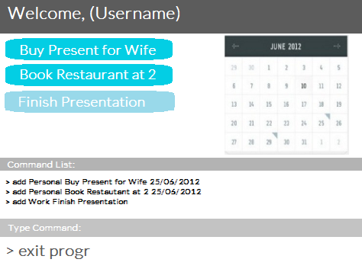

Supervisor: Ng Hui Xian Lynette   
Extra Feature: Google Integration

|  |  |  |  |
| --- | --- | --- | --- |
| Morgan James Howell  Team Lead, Storage API and Testing Lead, Git Expert | Rajendran Premkumar  Logic API Co-Lead, Integration | Xu Haoting  Logic API Co-Lead, Code Quality | Rebekah Low Jin Yan  UI Lead, Scheduling and Tracking |

# User guide

**About**

Are you a command-line addict? Are you looking for an easy-to-use schedule with the full functionalities of a to-do scheduler? Look no further. >$Clockwork is a to-do list scheduler runs entirely on user typed command. Through the command line interface, you may:

* Add, Create, Undo and Delete Tasks
* Search Tasks
* Allow Multiple Slots to be booked
* Upload To-Do Items on Google Calendar and Vice-Versa
* Use the QuickAdd command on Google Calendar
* Specify Folders to Archive Tasks
* Set Deadlines (Optional) for Tasks
* Move Tasks
* Label Tasks by Category
* Get Email Notifications as Reminders
* Set Generic Email Replies

>$Clockwork does all that and more! It is a simple tool that will display the tasks you have keyed in through the command line in an organized GUI.

It will export collated files formatted in text files. Example collated file: Username.txt

**Table of Contents**

* Quick Start
* Feature Details
  + Create, Read, Undo, and Delete Tasks (CRUD)
  + Search Tasks
  + Allow Multiple Slots to be booked
  + Upload To-Do Items on Google Calendar and Vice-Versa
  + Use the QuickAdd command on Google Calendar
  + Specify Folders to Archive Tasks
  + Move Tasks
  + Label Tasks by Category
  + Get Email Notifications as Reminders
  + Set Generic Email Replies
* Cheatsheet

**Quickstart**

1. Launch Clockwork.jar
2. In the ‘Type Command’ box as shown below, key in your command.

eg. exit program

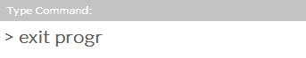

1. Press Enter to run the command\
2. Try more commands:
   1. add <category> <event name> <date> <time> - eg. add Personal Buy Present for Wife 25/06/2012
   2. remove <…>
   3. undo
   4. delete <category> <event name> - delete Personal Buy Present for Wife

To learn more about the full list of commands, refer to the ‘Cheatsheet’ section below.

**Feature Details**

* CRUD
  + Create Task
    - To create a task, use this command.   
      add <category> <event name> <date> <time>
    - Examples:   
      add Personal Buy Present for Wife 25/06/2012

add Buy Present for Wife

* + Read Task
    - To read a task, use this command.   
      add <category> <event name> <date> <time>
    - Examples:   
      add Personal Buy Present for Wife 25/06/2012

add Buy Present for Wife

* + Undo Task
  + Delete Task
* Search Tasks
* Allow Multiple Slots to be booked
* Upload To-Do Items on Google Calendar and Vice-Versa
* Use the QuickAdd command on Google Calendar
* Specify Folders to Archive Tasks
* Move Tasks
* Label Tasks by Category
* Get Email Notifications as Reminders
* Set Generic Email Replies

**Cheatsheet**

|  |  |
| --- | --- |
| **Command** | **Description** |
| add <category> <event name> <date> <time> | adds and colour codes the task based on the category specified |
|  |  |
|  |  |
|  |  |

# Appendix A: User stories. As a user, …

## [Likely]

|  |  |  |
| --- | --- | --- |
| ID | I can … (i.e. Functionality) | so that I … (i.e. Value) |
| [command] | add a task by specifying a task description only | can record tasks that I want to do some day |
| [command] |  |  |
|  |  |  |
|  |  |  |
|  |  |  |

## [Unlikely]

|  |  |  |
| --- | --- | --- |
| ID | I can … (i.e. Functionality) | so that I … (i.e. Value) |
| addFloating | add a task by specifying a task description only | can record tasks that I want to do some day |
|  |  |  |
|  |  |  |
|  |  |  |
|  |  |  |

# Appendix B: Non Functional Requirements

The software should run on Windows 7 or later.

The software able to perform even without network connections.

# Appendix C: Product survey

|  |
| --- |
| **Product**: {Product Name} **Documented by**: {The name of the team member who studied this product}  Strengths:  Weaknesses: |
|  |
|  |
|  |